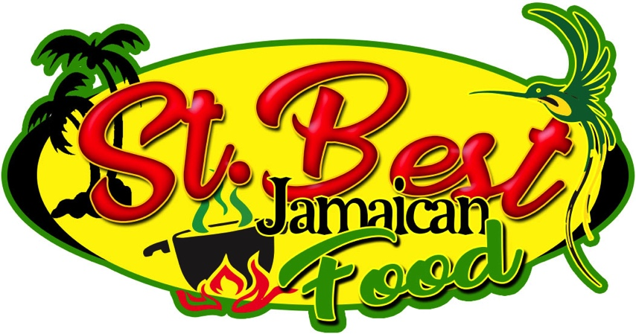

St. Best Jamaican Food pop up menu

Starter

Saltfish Fritters served with sweet chili sauce £ 5

Jerk Prawns served with salad £5

Main courses

Jerk Chicken served with rice and peas £9

Curry Goat served with rice and peas £9

St. Best Special

St. Best special Jerk Pork served with rice and peas £10

Vegan Combo - Chickpeas Curry , Callaloo, Stir fry Veg served with rice and peas £10

Sides

Plantain £3

Coleslaw £3

Stir fry veg £3

Desert

Jamaican Bread pudding £3.50

Fruit salad £3.00

